Create AJ Reports with Forena

This guide is intended to document the overall architecture of the Alerta Joven system.

**Revision History**

|  |  |  |  |
| --- | --- | --- | --- |
| **Number** | **When** | **Changes** | **Who** |
| 1.0 | 3/22/2015 | Initial creation of this doc to describe steps for creating Forena reports. | Vesselina Bakalov |
|  |  |  |  |
|  |  |  |  |

# Overview

Reporting for Alerta Joven web site was implemented by deploying the Forena Drupal module. This is a very flexible and low cost solution. To read more about Forena reporting go [here](https://www.drupal.org/project/forena). You can view Forena examples on Youtube to understand more about Forena reports. To access the reports go to Database->Reports page from the production [web site](http://107.20.181.244/). The ConfigureForenaReportswithPDF.docx explains how export to PFD was configured. The location of modified Forena files and the queries is:

|  |  |  |
| --- | --- | --- |
| **Local Location** | **Server Location** | **Description** |
| forena\reports | apps/drupal/htdocs/sites/default/files/reports | Customized skin files. |
| forena\sql\alertajoven | apps/drupal/htdocs/sites/default/sql/alertajoven | The queries used to generate the reports. |

This document will describe the steps to create Forena report.

# Step 1 – Create SQL Query

All sql queries used to create the reports are located under the coconut_repository/forena/sql folder. For the purpose of this example we will create a new report ‘Exit Participants” that will query all participants that exited the program. The document assumes you can connect to the production database and query data. The exit data are loaded from couchDB into the Drupal MySQL data through the ajetlexit module into the aj_exit table. The SQl query is:

*-- ACCESS=access content*

*SELECT reg.Nombre, reg.Apellido, reg.dob, ex.\**

*FROM*

*bitnami_drupal7.aj_exit ex*

*join bitnami_drupal7. aj_registration reg ON reg.uuid = ex.uuid*

*join bitnami_drupal7.field_data_field_agency_name provider on provider.entity_id=ex.provider_id*

*and ex.provider_id = :provider_id*

*GROUP BY ex.uuid*

*order by reg.Apellido*

We will save the query into src_repository/forena/sql/Exit.sql. There are 2 interesting things:

1. --Access=access content is used for Forena to identify access to the report. All reports need to have this access.
2. :provider_id is a Forena parameter.

This file need to be copied to the production server. To do that use FTP session to login to the production server. You need to have FTP installed and use the command below:

*psftp.exe bitnami@107.20.181.244 -i drajovenAWSkey.ppk*

After you ftp to the production server go to the Forena repository and upload the Exit.sql by typing:

*>cd apps/drupal/htdocs/sites/default/sql/alertajoven*

*>put Exit.sql*

# Step 2 – Create Report from AJ/Drupal using Forena (in English)

1. Login to AJ web site as Admin.
2. Select Structure/Forena Reports

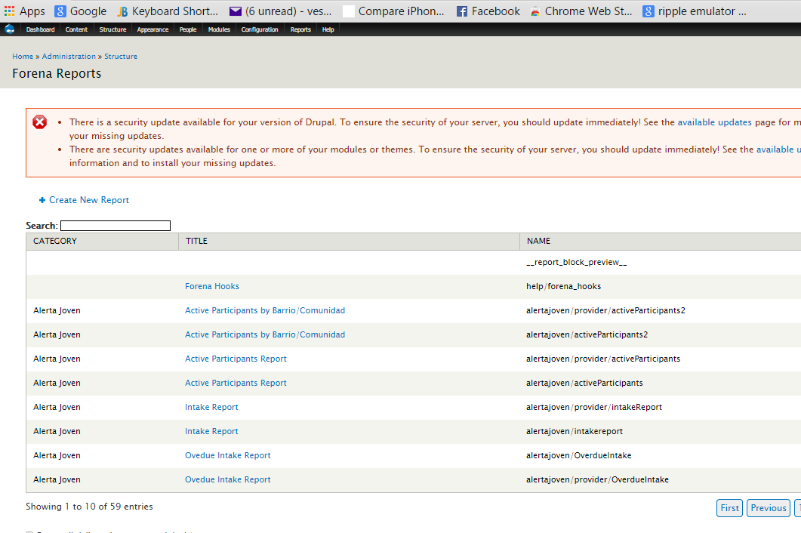

1. Select ‘Create New Report” link.
2. Enter values into the fields as shown on the screen below and select “Create”

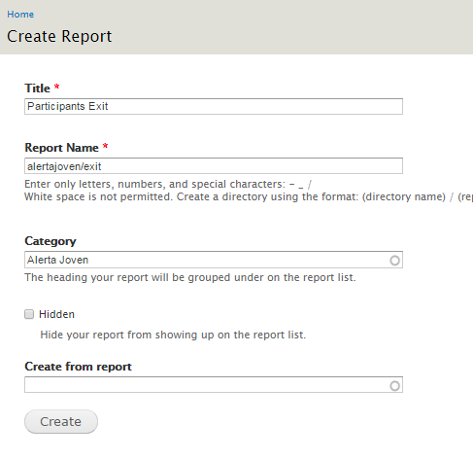

1. Click on Data tab from the screen below:

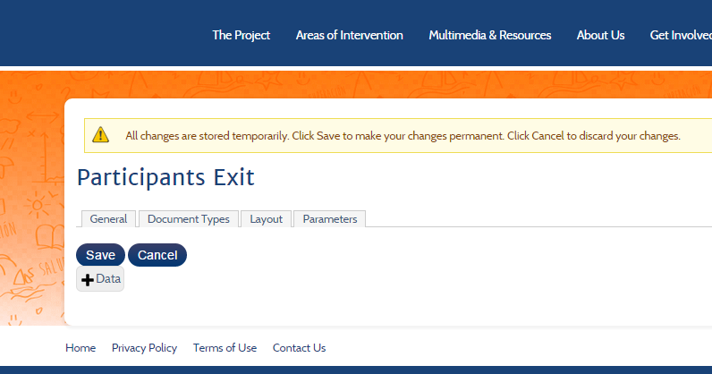

1. Select AlertaJovenReportingDataSource/Exit data block from the screen below.

***Note:*** the block will show since we ftp the Exit.sql to the alertajoven reporting folder on the production server in step 1.

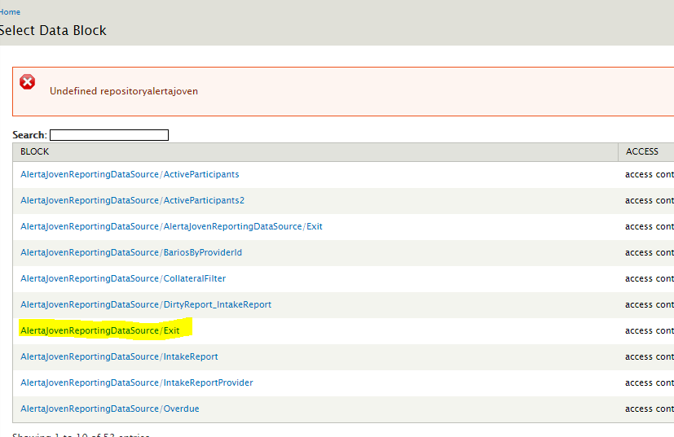

1. Now you need to enter valid value for the provider_id parameter to have some sample data for Forena to create the report. In this case we have some data into the aj_exit table for provider_id = 39 so we enter 39 (this is the provider id for Dream Project organization).

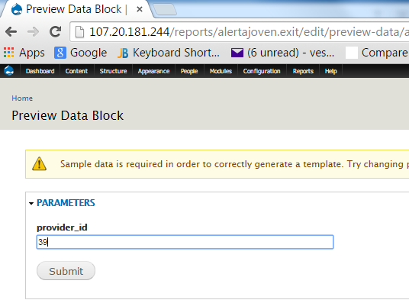

1. Click on Submit. You will see the following screen:

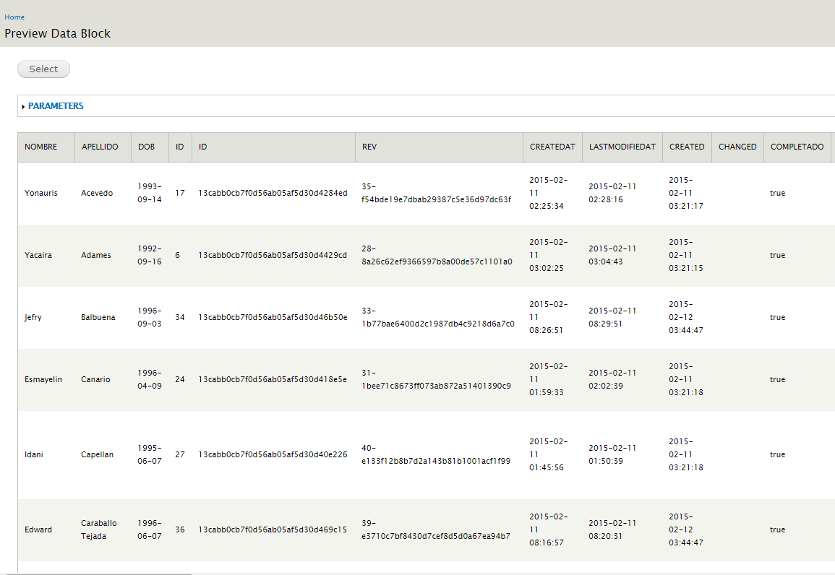

1. Click on Select button. We can uncheck some of the result data we don’t want to show in the report such as: id, _id, created, createdAt, etc… Just leave the data you want to see in the final report.

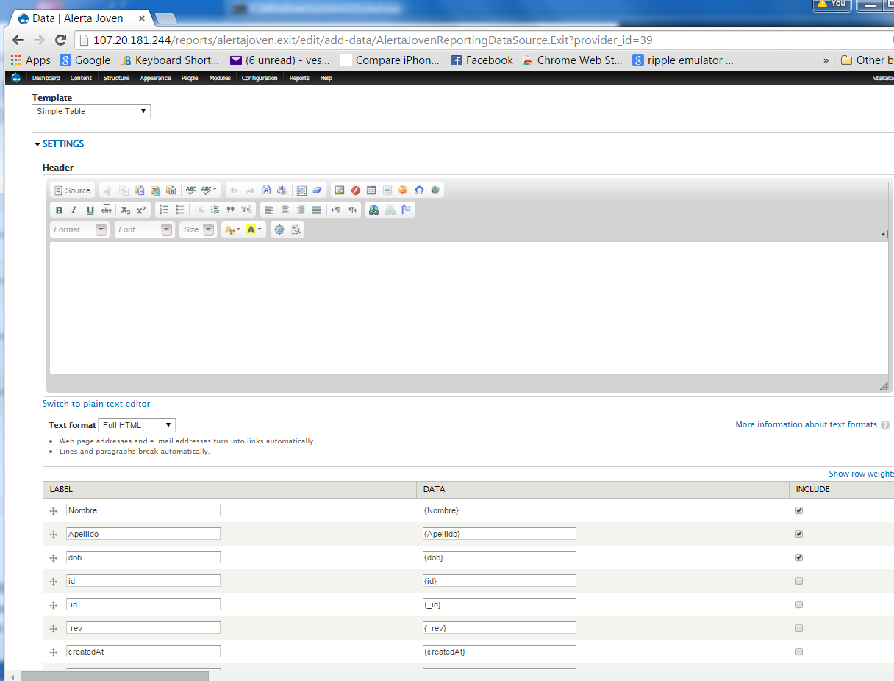

1. Click on Preview and if you are happy with the results click on the Add button on the top. At this point the Exit data block is associated with the report and all changes are stored temporary. To save the changes permanently click on the “Save” button.

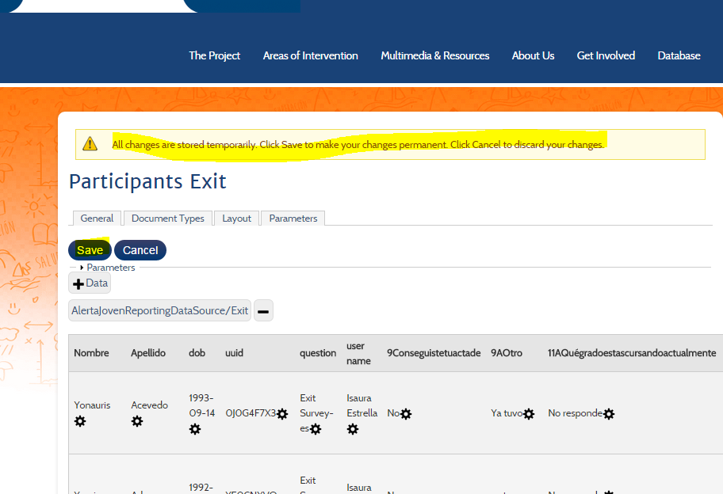

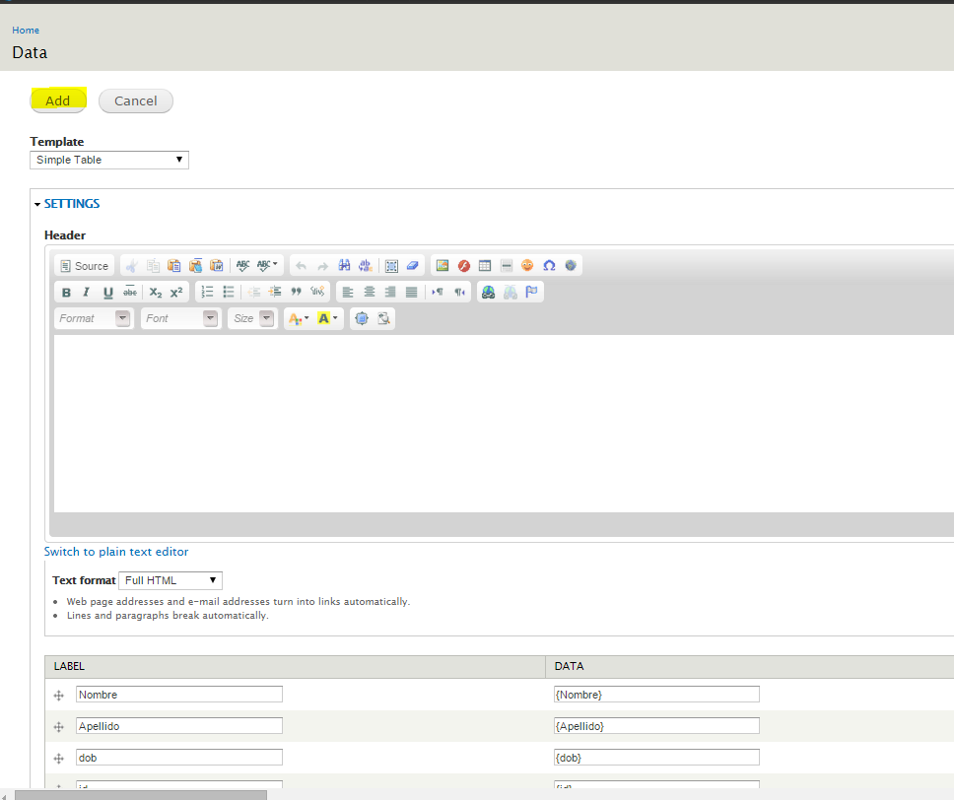

1. Click on the edit icon to continue with the report configuration.

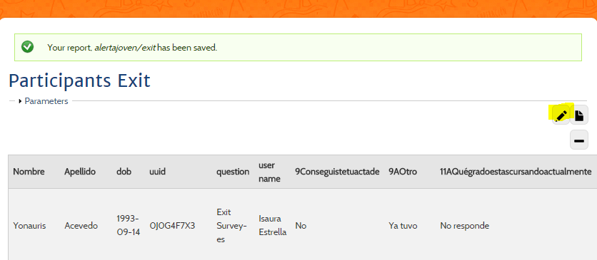

1. Click on the “Document Types” tab to configure download options for the report.

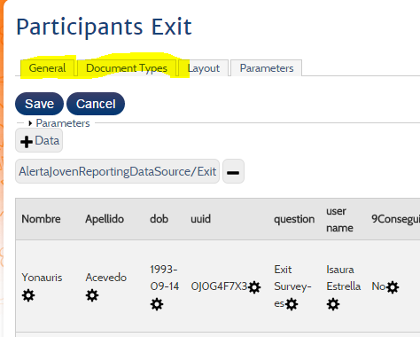

1. Select CSV and PDF since for most of the reports we want them to be downloadable in both formats and click on the Update button to save the selection. It is a good practice to “Save” your changes after every update to preserve the changes permanently as explained in Step 10.

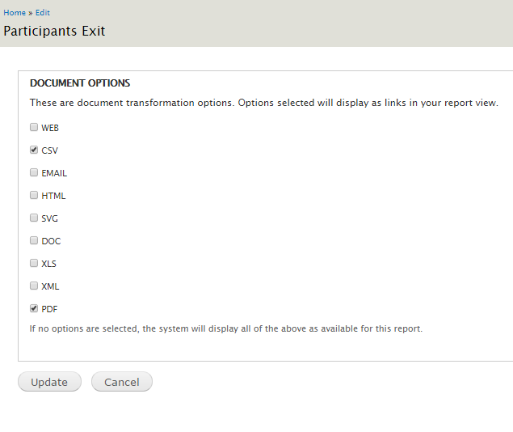

1. Select the “Layout” tab next.

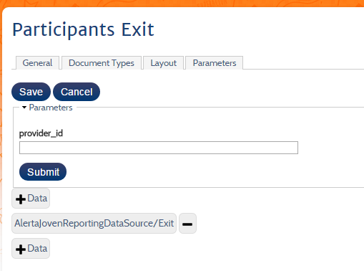

and click over the Source tab.

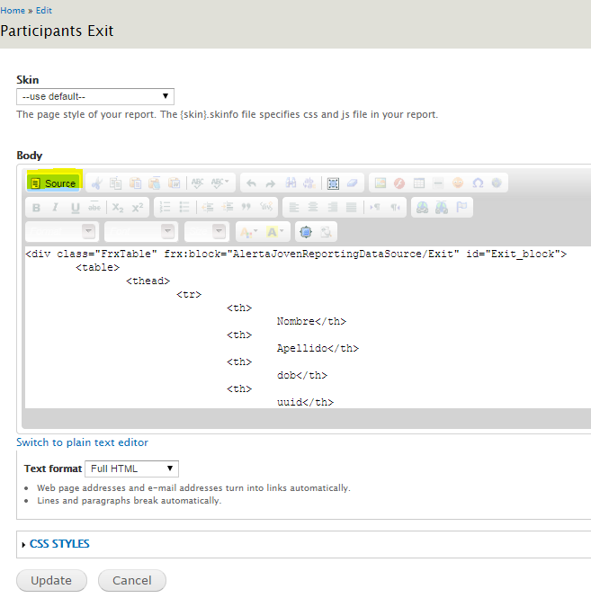

Modify the div and table tags by adding the following:

<div class="FrxTable" frx:block="AlertaJovenReportingDataSource/Exit" id="Exit_block" style="overflow:auto;">

<table id="ajActiveParticipants">

The “overflow:auto” will ensure the report has horizontal scroll bar and the table id will use jQuery styling that is configures already to work with Forena. **Click on Update button to Save your changes permanently.**

1. Configuring Parameters.

Click on the Edit icon again and this time select the “Parameters” tab.

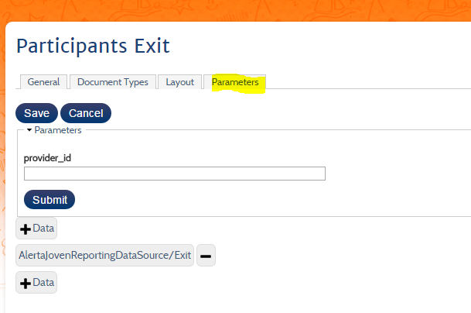

From the parameter screen below click over “Configure parameter” icon:

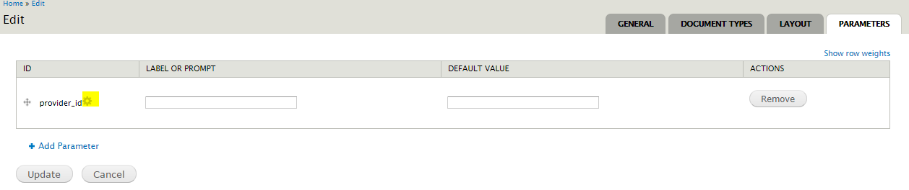

Enter the highlighted values for Name, label, required, etc. This will configure the Select Provider drop down parameter so the end user can select provider. The AlertaJovenReportingDataSource/ProvidersByRole block is used to populate the list. You can view the ProvidersByRole sql query by opening the coconut_repository/forena/sql/alertajoven/ProvidersByRole.sql file.

Click on the “Update” button after you enter the values and “Save” to save your changes permanently.

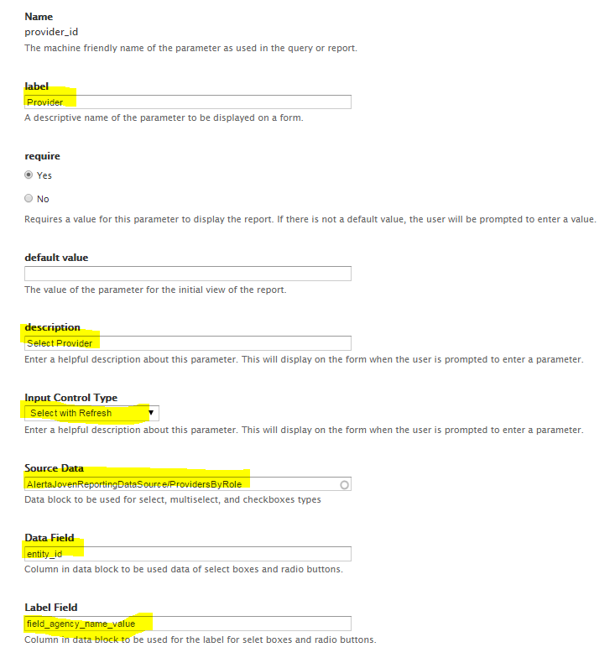

Click on “Update” again to save the parameter.

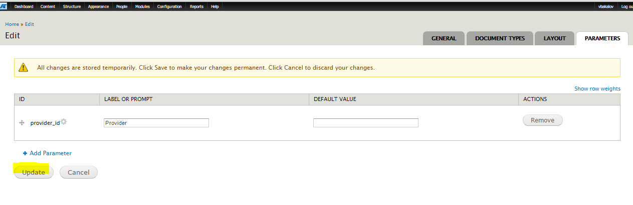

1. Testing the report. To test the report select “Dream Project” (because we know we have exit data for this project) from the populated with providers drop down list and click on “Submit” button.

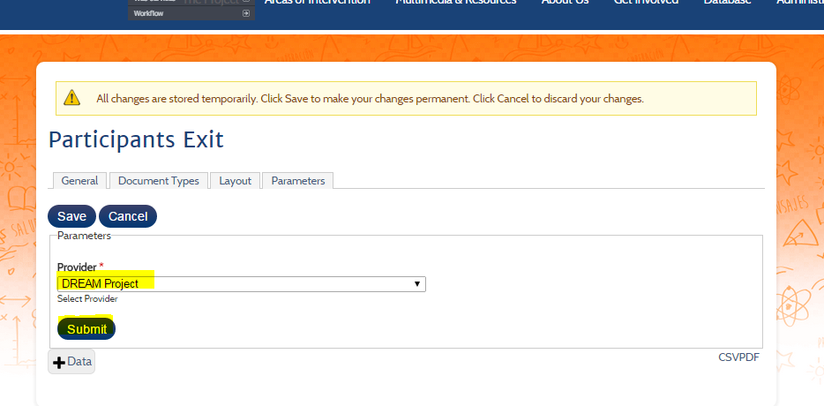

You will see the finale report. If you are happy with the results **click on “Save” button to save the changes permanently**.

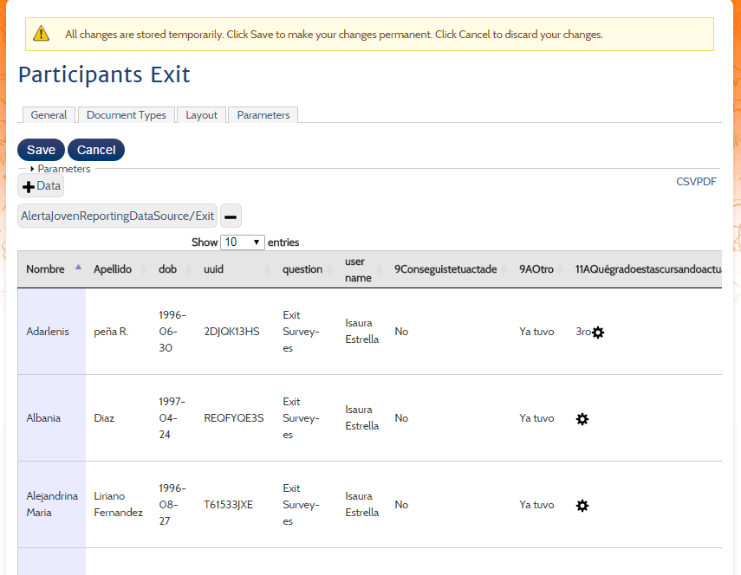

1. Make the report visible to evaluators and providers.

To view the link for accessing the report go to Structure->Forena Reports and check the url for our report. From the list below it is alertajoven/exit. This is the name we need to use as url.

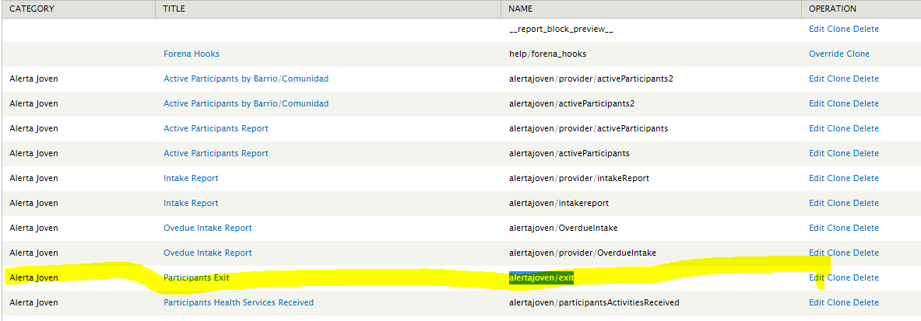

1. Make report visible to evaluators.

To do that simply click on the Database/Reports link and select the “Edit” tab.

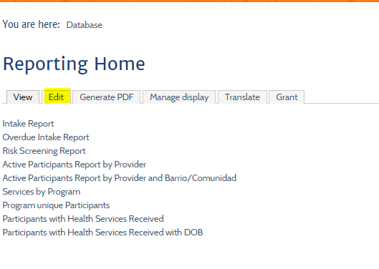

Select the “Source” tab.

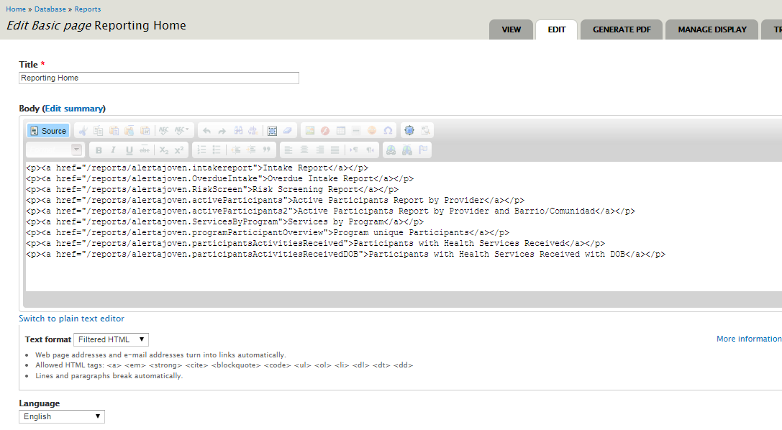

Add the new link:

<p><a href="/reports/alertajoven.exit">Exit Participants Report</a></p>

Save your changes by clicking the “Save” button:

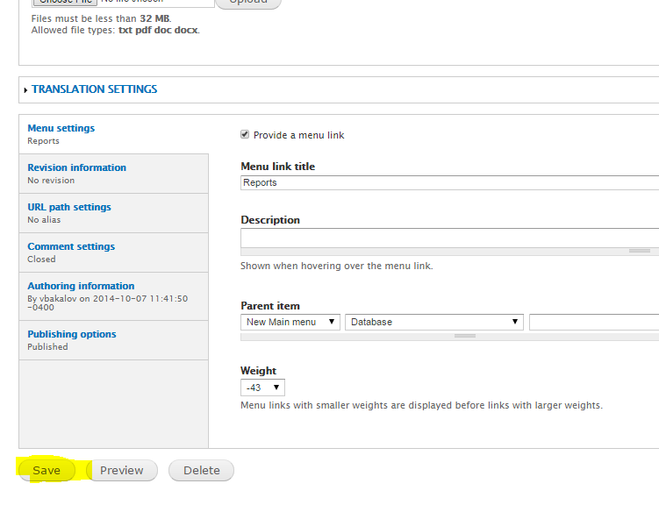

You will see the new link on the Database->Reports page.

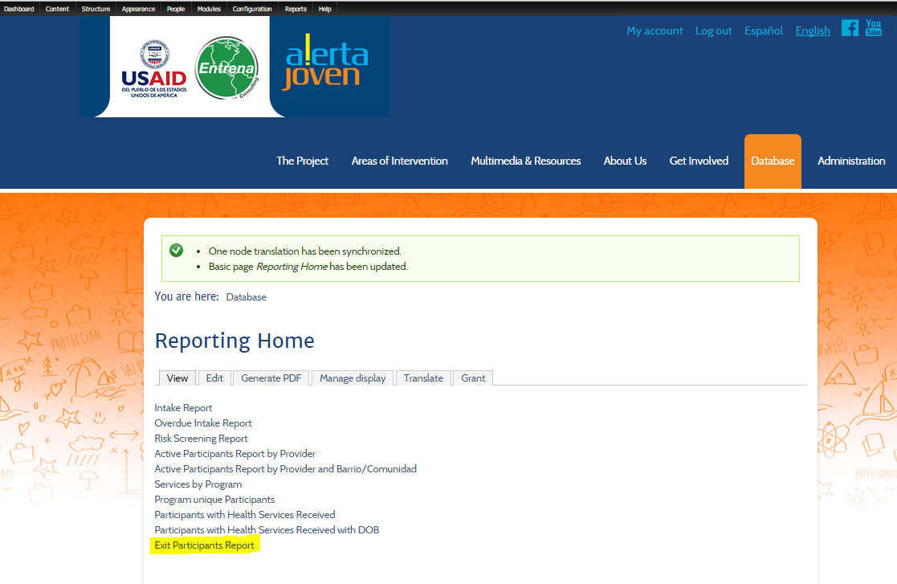

At this point the report is visible to users who have Admin and Evaluator privileges.

1. Making the report visible to providers.

Click over the “List Links” menu. Click on the “Provider Reports” link under Database.

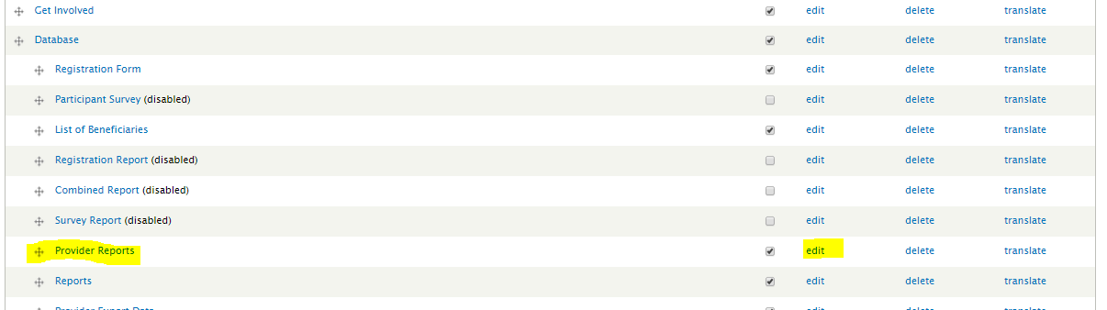

You will see the provider reporting page:

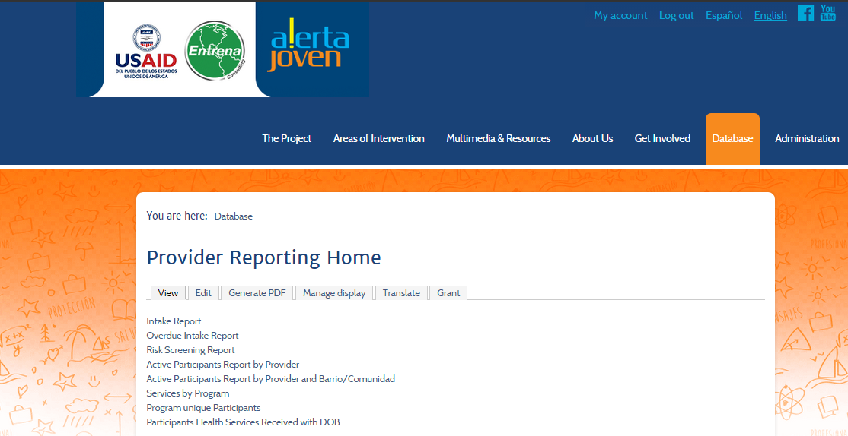

Click the “Edit” tab. Click on source and add the same link to the report.

<p><a href="/reports/alertajoven.exit">Exit Participants Report</a></p>

**Don’t forget to click on the “Save” button at the bottom of the page.**

To test the report for provider login as testProvider. Be sure to assign this test user to “Dream Project” to ensure there will be some results. To do that, select “People” link at the top. Find the “testProvider” user by sorting the list by Username and Click on “edit”.

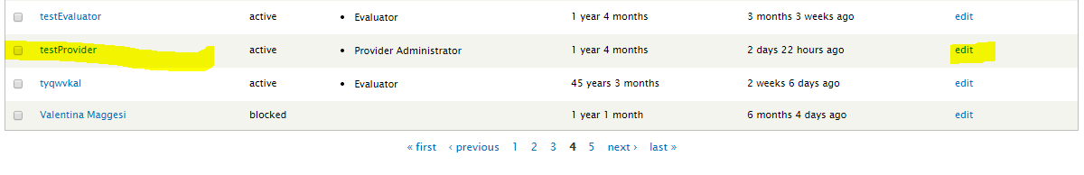

Scroll down to the end of the page and select “Dream Project” for Provider. Click on Save.

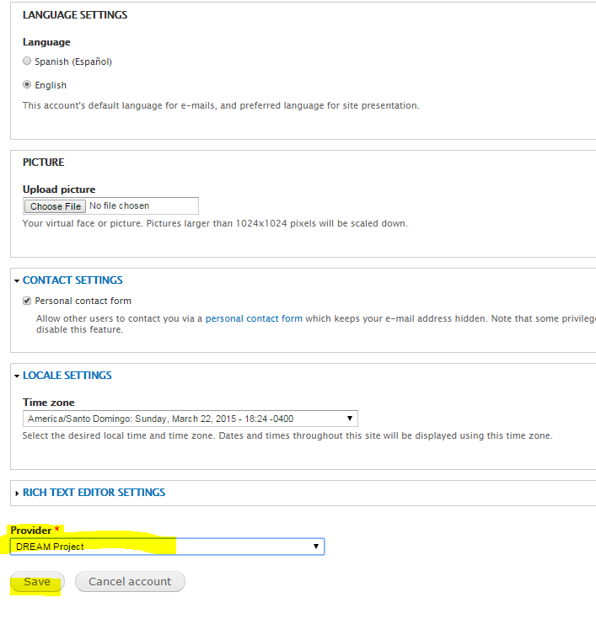

Log out and login again as “testProvider”

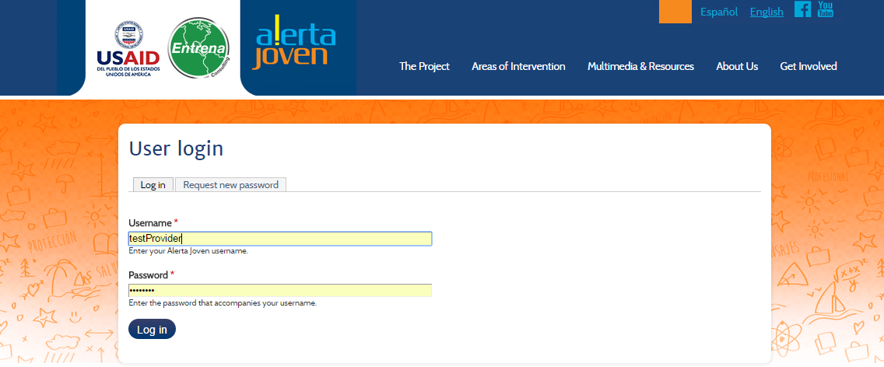

Click on Database->Provider Reports link

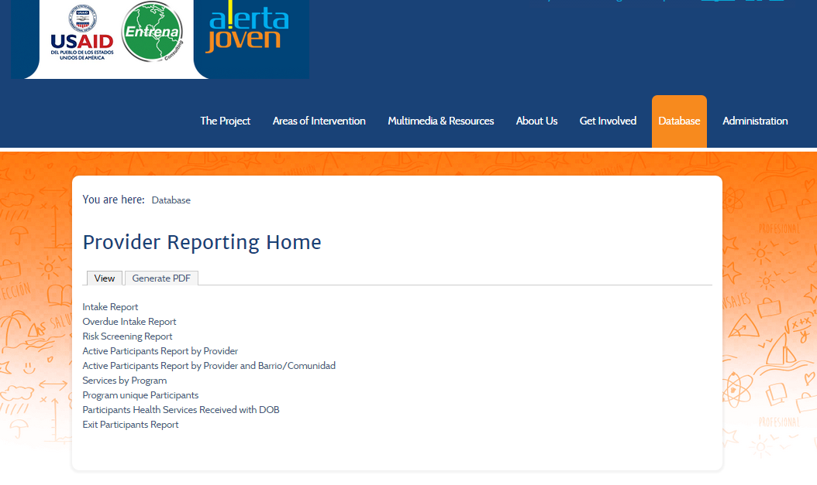

Click on Exit Participant Report link. You will be able to select **only one option**, e.g. “Dream Project” since you are provider for Dream Project organization. This ensures that the report works correctly.

***Note: evaluators and administrators see all providers. Providers and case managers should see only data for organization they belong***.

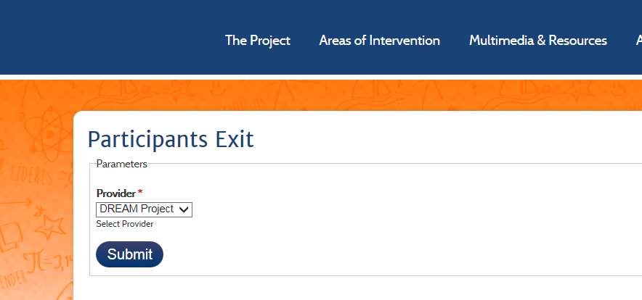

# Step 3 – Translating the Report in Spanish

1. Login as admin and select Structure->Forena Reports to view the reports. Click on the “Participants Exit” report. Click on the “Translation” icon on the bottom right.

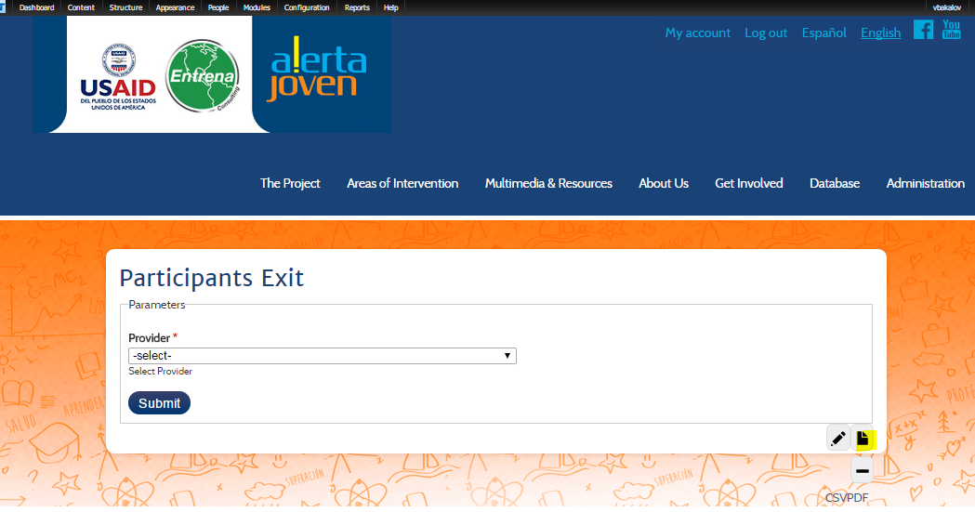

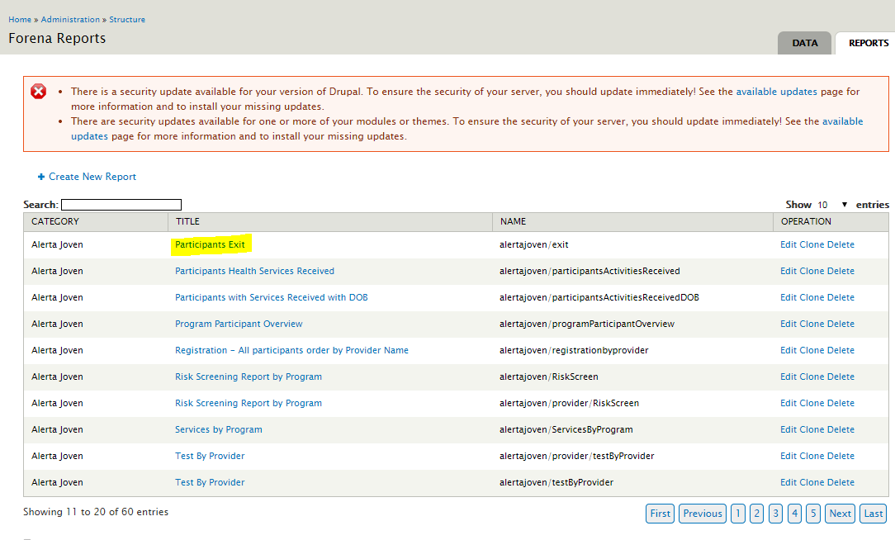

Select “Agregar” from the screen below:

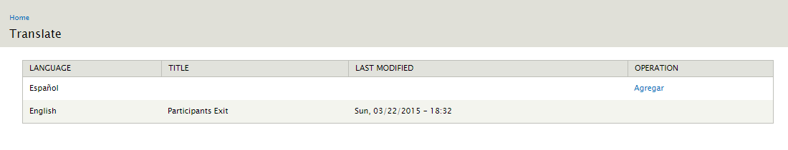

Enter the report title in Spanish.

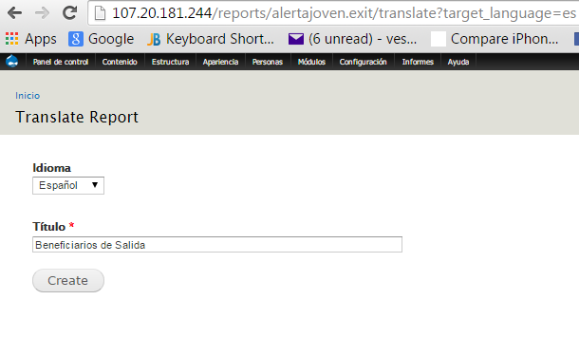

Click on “Create”.

Go to Home and select Spanish language.

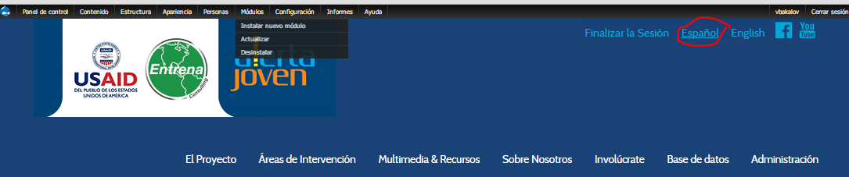

Select Structure-> Forena reports (this is in Spanish now). Click on “Editar” for “Beneficiarios de Salida” report. Unfortunately we have to configure the report again for the Spanish version.

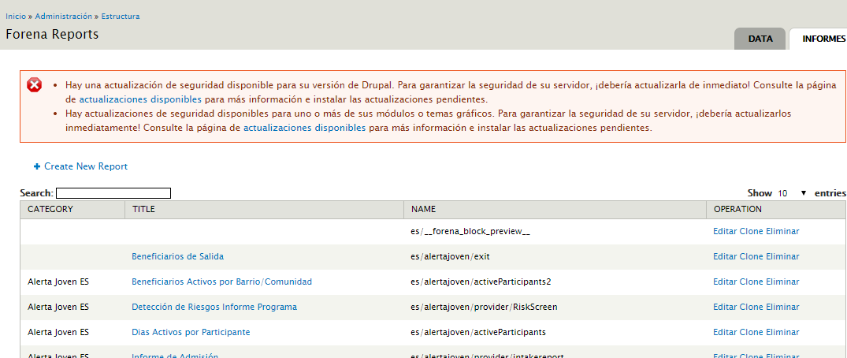

1. Select the “General” tab.

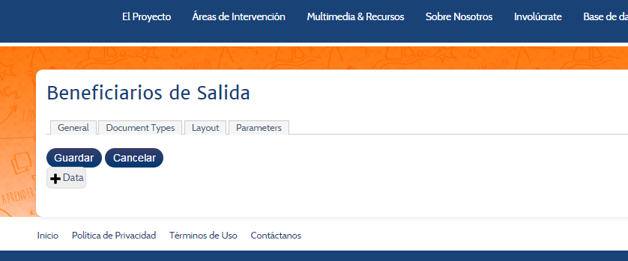

Enter “Alerta Joven ES” into the **Categoría** field and click on “Actualiza” to preserve the changes.

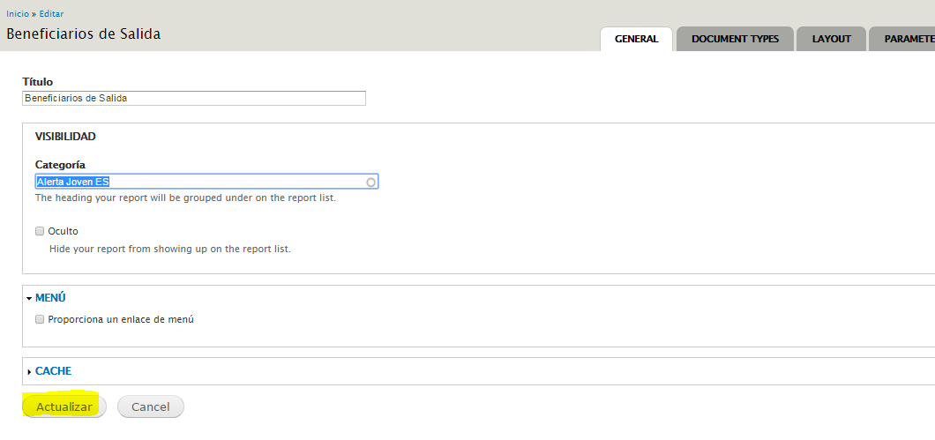

**IMPORTANT: After every change click on “Guardar” button to save the changes permanently.**

1. Associate Data Block.

Click on the Data icon below:

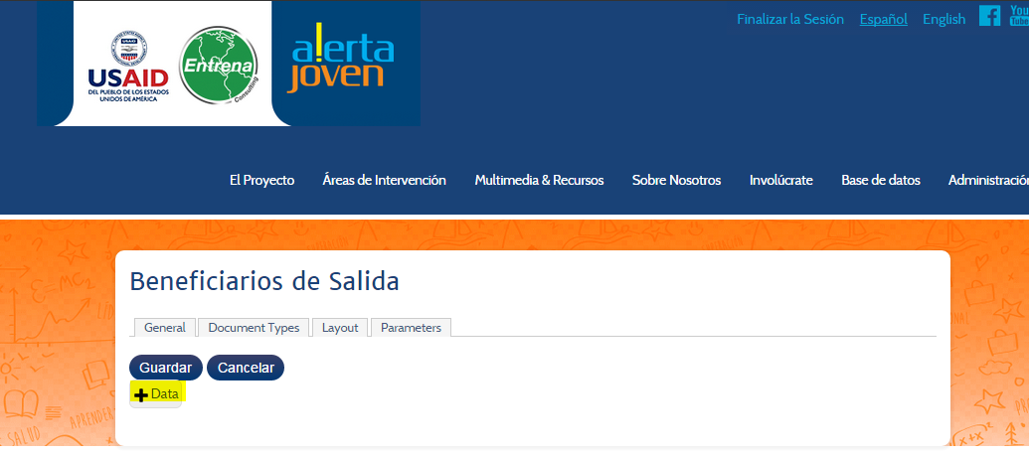

Select the “[AlertaJovenReportingDataSource/Exit](http://107.20.181.244/reports/es.alertajoven.exit/edit/preview-data/add-data/AlertaJovenReportingDataSource.Exit)” data block. Enter for provider_id=39 and for Collateral = All.

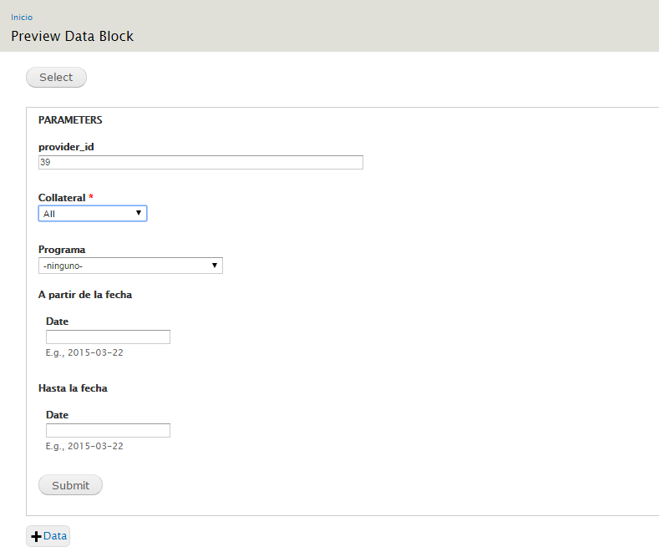

Click on Submit button. It will preview the data block:

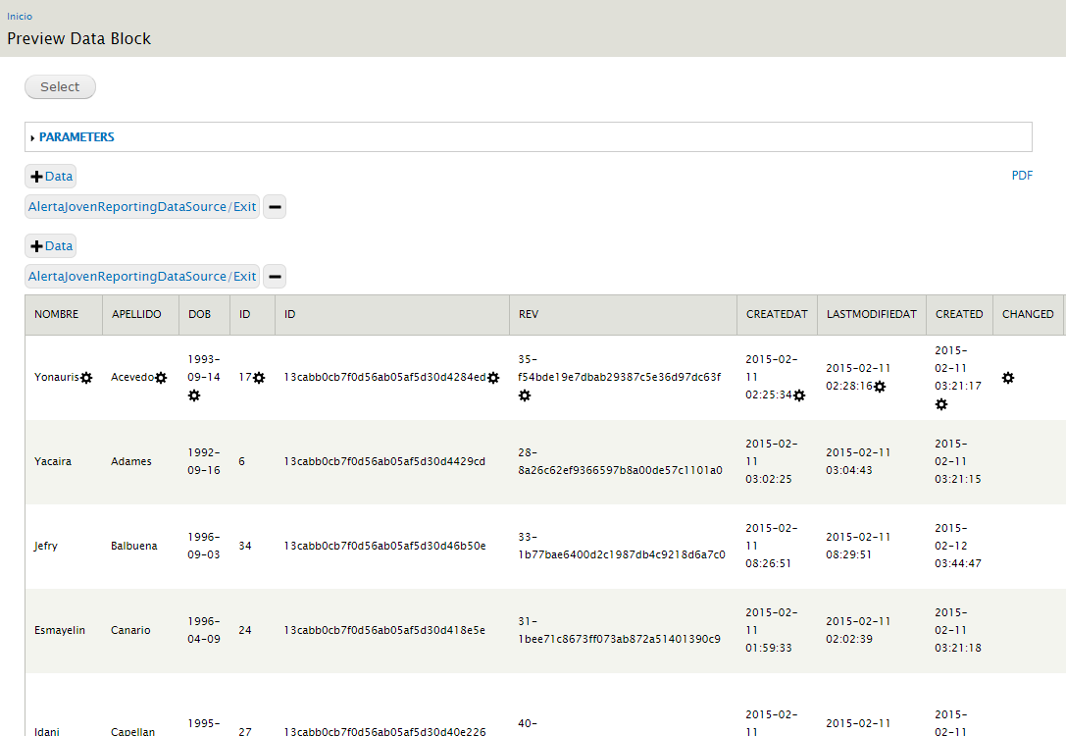

Click on “Select” again.

From the screen below, uncheck fields like id, _id, rev, etc. that you don’t want to see in the final report and click on the “Add” button to associate this block with the report.

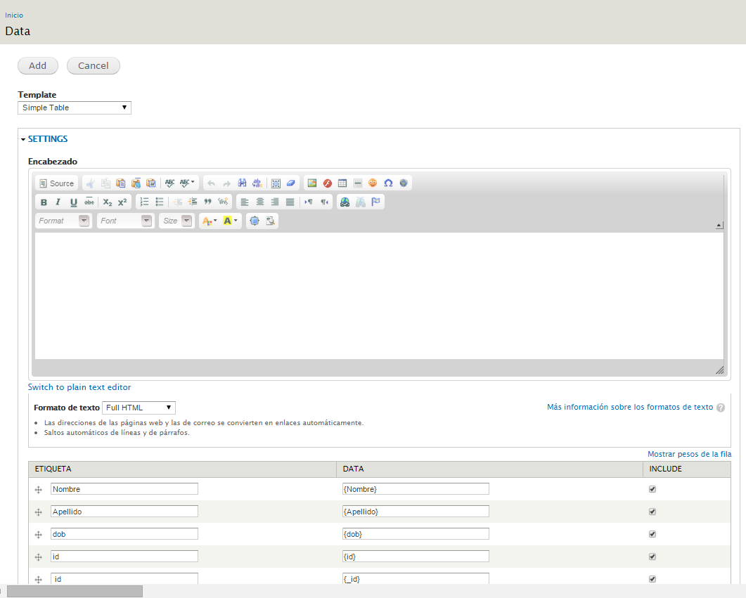

Click on “Guadar” to save your changes permanently.

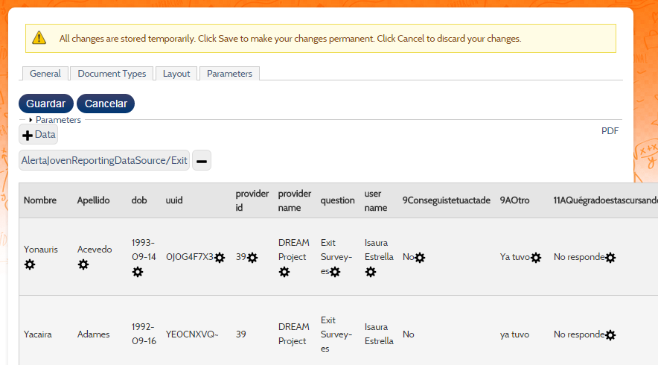

1. Configure Document Type.

Select the Document Type tab and check PDF and CSV boxes. Click on ‘Update” button.

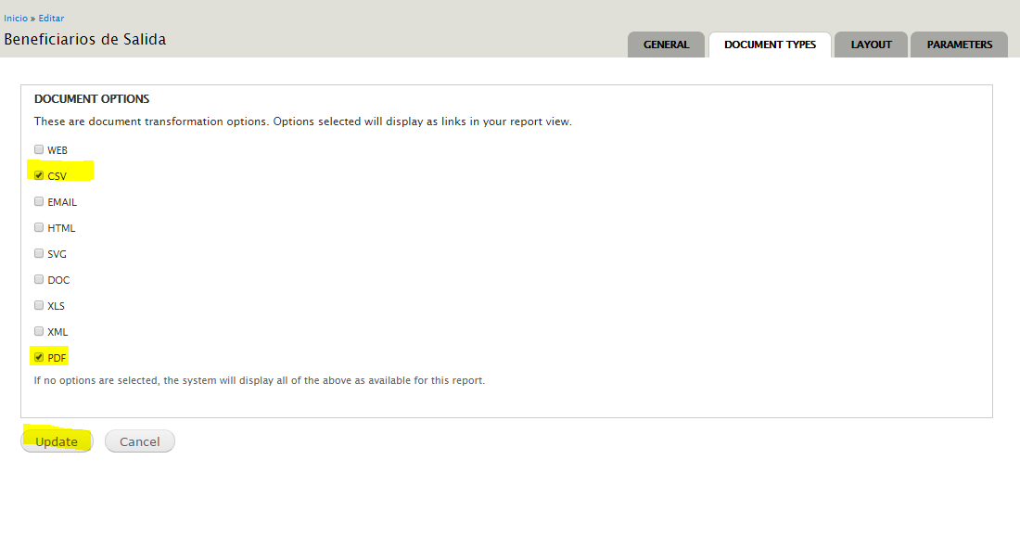

Click on “Guadar” to save your changes permanently.

1. Configure Report Layout.

Click on the “Layout” tab.

Hint: you can copy the layout from the English version. To do that in another browser open the report for edit in English and copy the layout from the English version to the Spanish version.

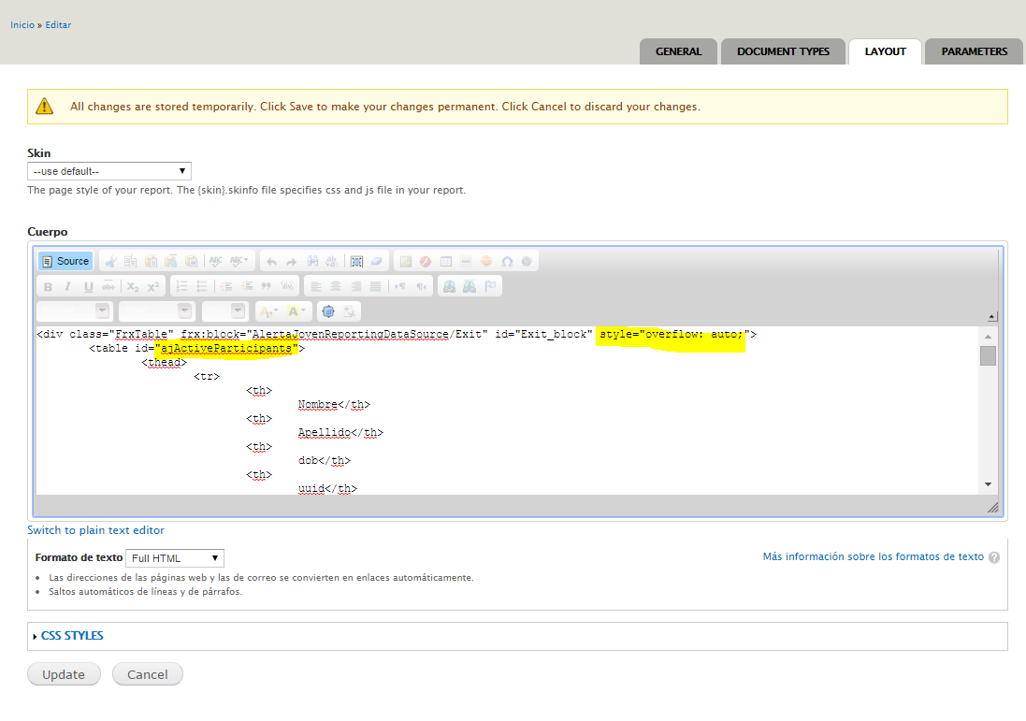

You also have to change table headers to Spanish if needed. For example dob should be changed to “Fecha de Nacimiento”. Look for other columns too.

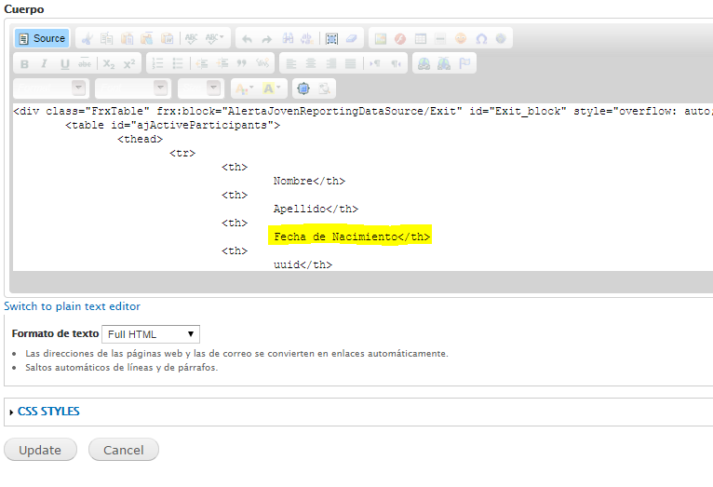

Select “Guardar” to save the Layout changes.

1. Configure Parameters.

To configure the report parameters select the “Parameters” tab from the screen above. Eliminate the collateral, program_id, from_date and to_date parameters.

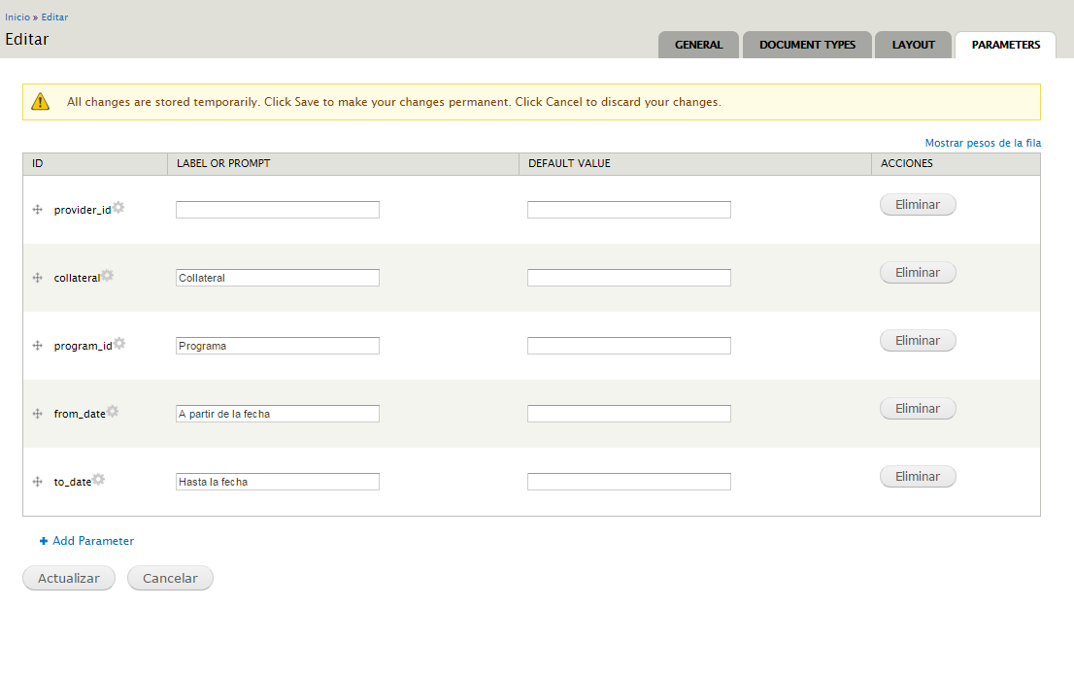

The result screen should have only the provider_id parameter.

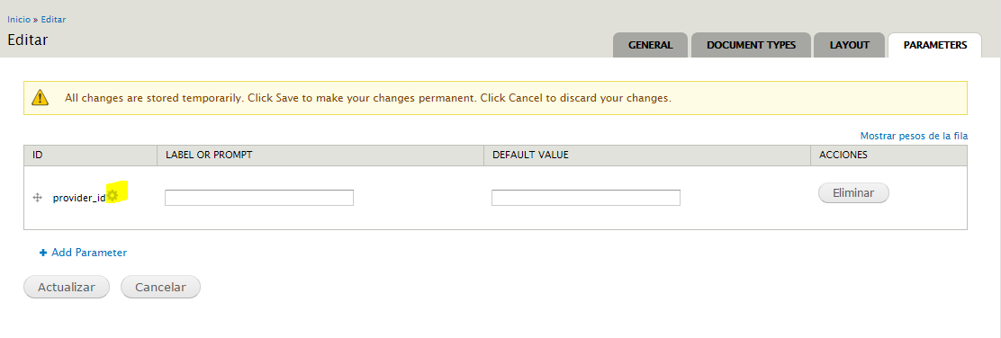

Click on the “Configure Parameter” icon that is highlighted.

You can copy the parameter configuration from the English version of the report but change the parameter label to Spanish. You should have the following at the end:

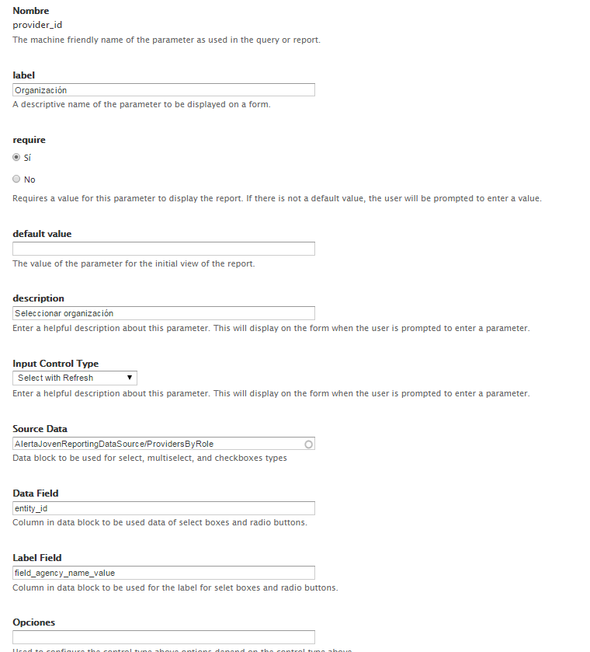

Click on Update button and Guardar to permanently save the changes.

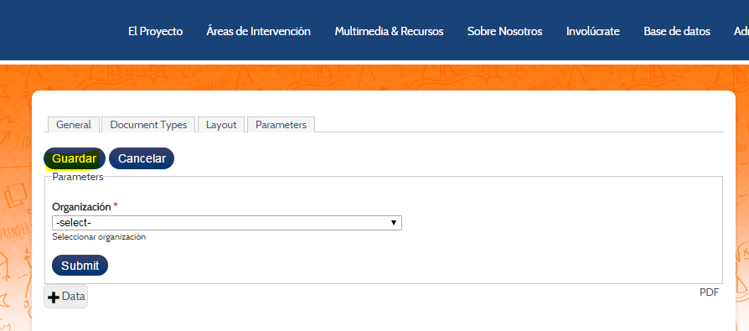

1. Testing the report.

From the screen above select organization “DREAM Project” and review the report.

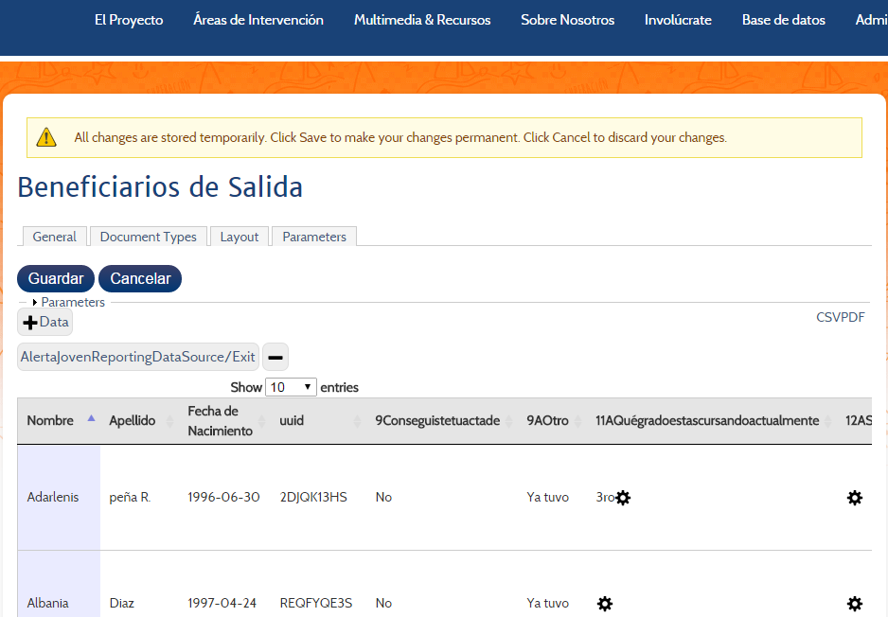

1. Make report available to users.
   1. Make report available to users with admin and evaluator roles.

Select “Base de datos”->Reportes en Linea menu option.

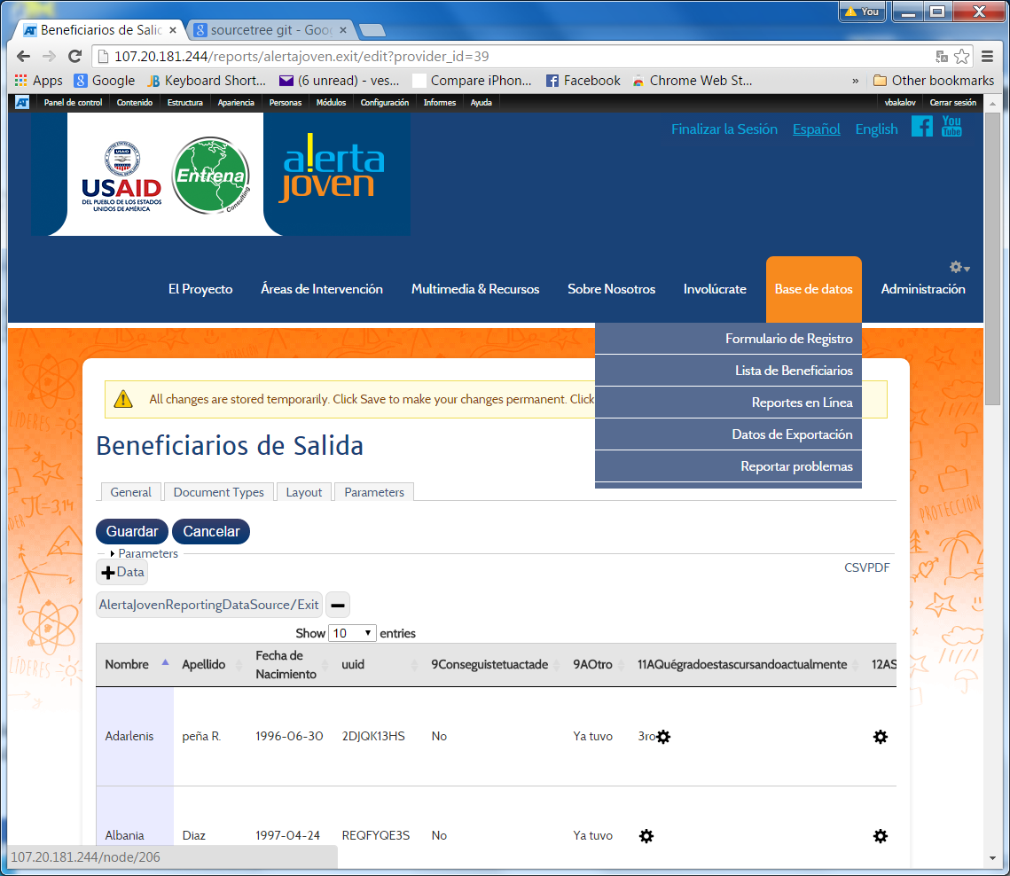

Select Editart tab and Source tab.

Add the link to access the exit report link in Spanish:

<p><a href="/reports/alertajoven.exit">Beneficiarios de Salida</a></p>

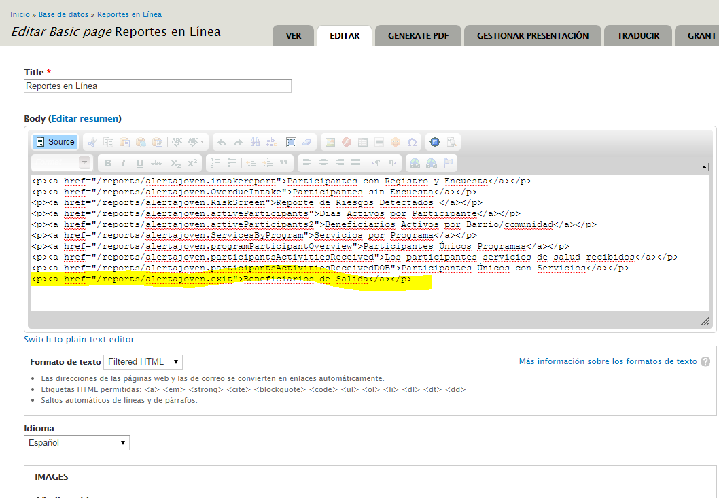

Click on the “Guardar” button at the bottom of the page to save your changes.

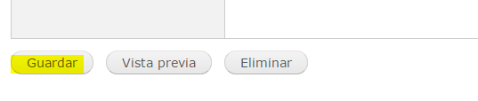

Test the report by selecting the report link.

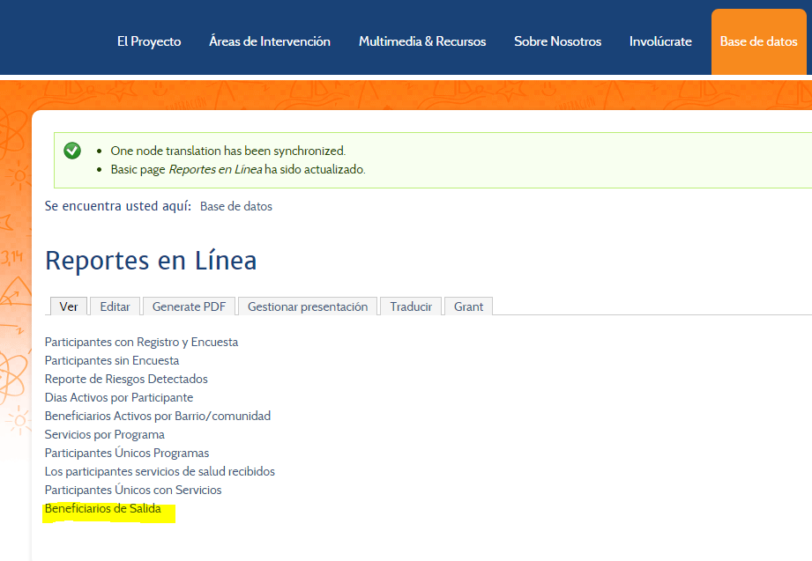

* 1. Make Report Available to Providers.

Select “Listas Enlaces” from the edit menu link (see below).

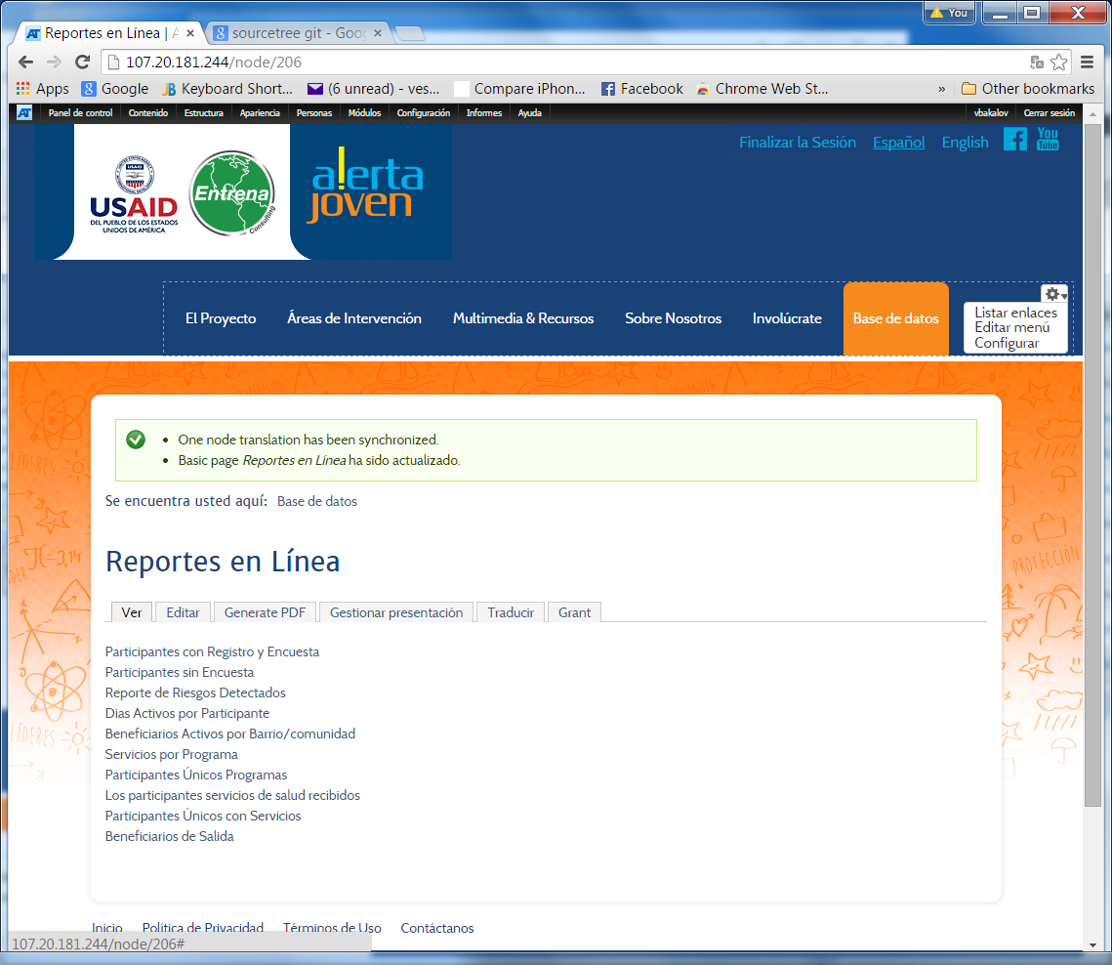

Click on “Provider Informes” link.

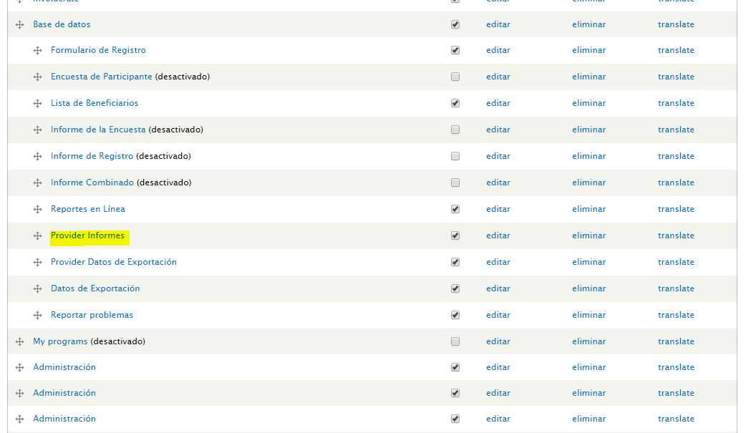

Select Editar tab.

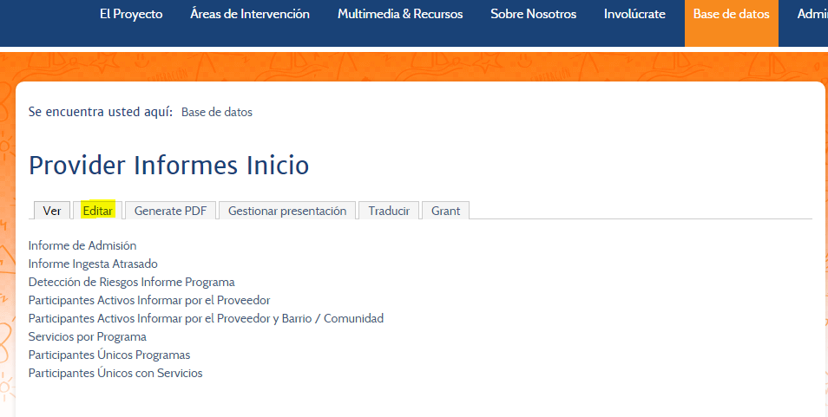

Add the link to access the exit report:

<p><a href="/reports/alertajoven.exit">Beneficiarios de Salida</a></p>

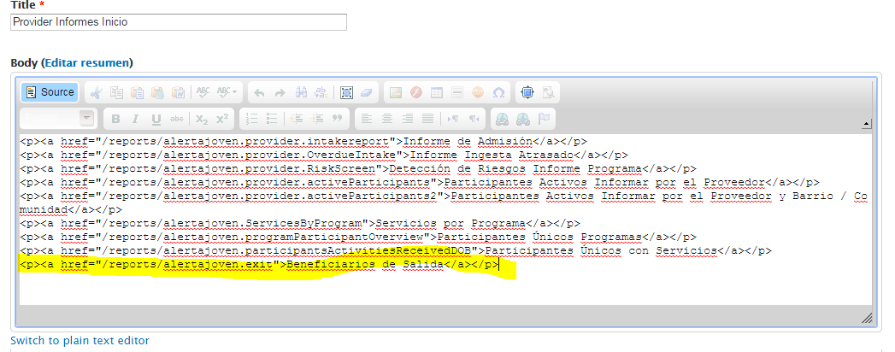

Save the changes by clicking on the Guardar button at the bottom of the page.

1. To test the report as provider logout and login as testProvider. Please read section “2 Making the report visible to providers” to understand how to configure provider from DREAM Project organization.

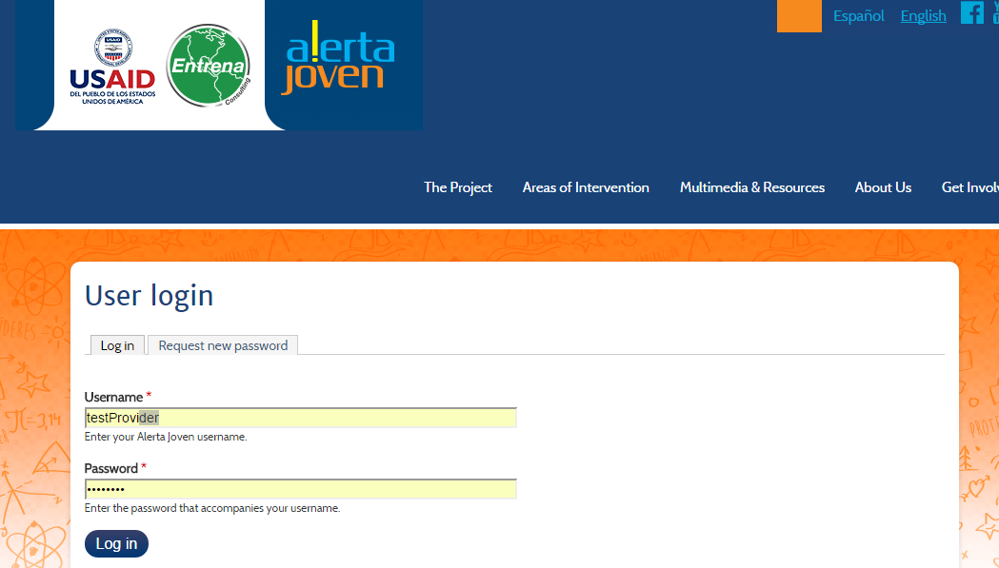

Select “Base de datos”->”Provider Informes” menu option. Click on the “Beneficiarios de Salida” link.

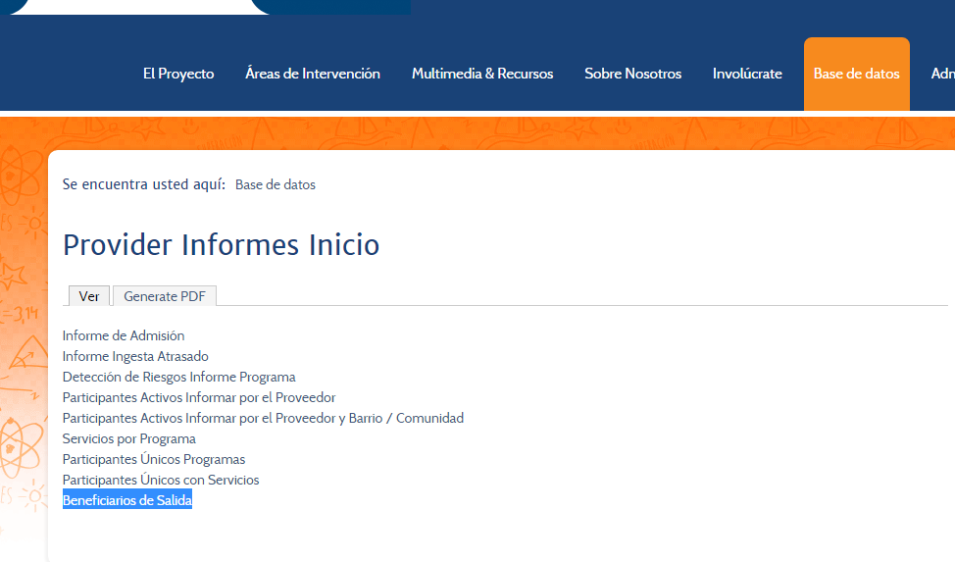

Ensure the “Organización” drop down list shows **only** “DREAM Project” option. This is because providers and case managers can view only data for the organization they belong.

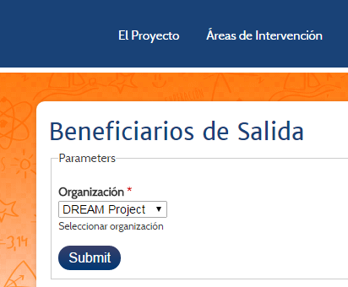

Click on Submit and review the final report